REAL-TIME AUTOMOTIVE CONTROL SYSTEM ECU Sensor Dashboard & Monitoring System

Project Documentation

Version 1.0

Submitted By:
Harshit Khandelwal
Ritul Dani
Vinayak Ranjanagi

Date: 27th October 2025

GitHub Repository:
github.com/harshitkhandelwal17/
Real_Time_Automotive_Control_System

TABLE OF CONTENTS
- Executive Summary
- Introduction
  - Project Overview
  - Objectives
  - Scope
- System Architecture
  - Overall Architecture
  - Component Interaction
  - Data Flow
- System Components
  - sensor.c - Main ECU Process
  - subsystem.c - Controller Process
  - UI.c - Terminal Dashboard
  - server.c - Web Dashboard
  - signal.c - Control Panel
- Technical Implementation
  - Inter-Process Communication
  - Multi-Threading
  - Signal Handling
- Sensor Simulation & Controller Logic
- Crash Safety System
- User Interfaces
- Installation & Usage Guide
- Testing & Results
- Future Enhancements
- Conclusion

1. EXECUTIVE SUMMARY
The Real-Time Automotive Control System is a comprehensive simulation of an
Electronic Control Unit (ECU) that demonstrates advanced systems programming
concepts including inter-process communication, multi-threading, and real-time data
processing. This project successfully implements a fully functional automotive
monitoring and control system using C programming language on a Linux platform.

The system consists of five integrated components working in harmony through shared
memory IPC: a main sensor process, a subsystem controller process with six
independent threads, a terminal-based user interface using NCurses, a web-based
dashboard with HTTP server, and an external control panel for ignition management.
The system simulates real-world automotive scenarios including sensor data
generation, automated controller responses, and emergency crash detection with
automated safety protocols.

Key achievements of this project :
- Implementation of System V shared memory for efficient inter-process Communication
- Development of six concurrent controller threads for automated system management
- Real-time crash detection with 2% probability at high speeds triggering comprehensive emergency response
- Dual interface design providing both terminal-based and web-based monitoring capabilities
- Thread-safe operations using pthread mutex locks preventing race conditions

2. INTRODUCTION
2.1 Project Overview
Modern automobiles contain sophisticated Electronic Control Units (ECUs) that
manage various vehicle subsystems including engine management, safety systems,
climate control, and transmission. This project simulates a real-time ECU system that
monitors sensor data and controls various automotive subsystems automatically.

The system architecture employs multiple processes communicating through shared
memory, demonstrating practical applications of operating system concepts such as
IPC, process synchronization, signal handling, and concurrent programming. The
implementation showcases how complex automotive systems can be simulated using
systems programming techniques.

2.2 Objectives
The primary objectives of this project are:
- Educational: Demonstrate advanced systems programming concepts including IPC, threading, and signal handling in a practical real-world scenario
- Functional: Create a fully operational automotive ECU simulation with realistic sensor data and automated control systems
- Safety-Focused: Implement comprehensive crash detection and emergency response mechanisms
- User-Friendly: Provide intuitive interfaces for both terminal and web-based monitoring
- Scalable: Design an architecture that can be extended with additional sensors and controllers

2.3 Scope
This project covers the following aspects:
- Simulation of seven automotive sensors (engine temperature, speed, fuel level, gear position, obstacle detection, inside temperature, and crash status)
- Implementation of six automated controller systems (fan, AC, brake, light, safety, and fuel)
- Real-time data processing with 3-second update intervals
- Crash detection algorithm with automatic emergency response
- Multiple user interfaces for system monitoring and control
- Thread-safe shared memory operations
- External process control through POSIX signals
The project does not include actual hardware integration, CAN bus protocols, or connection to real automotive sensors, focusing instead on software simulation and architecture.

3. SYSTEM ARCHITECTURE

3.1 Overall Architecture
The system follows a multi-process architecture with five independent processes
communicating through System V shared memory. This design promotes modularity,
fault isolation, and parallel execution of different system components.

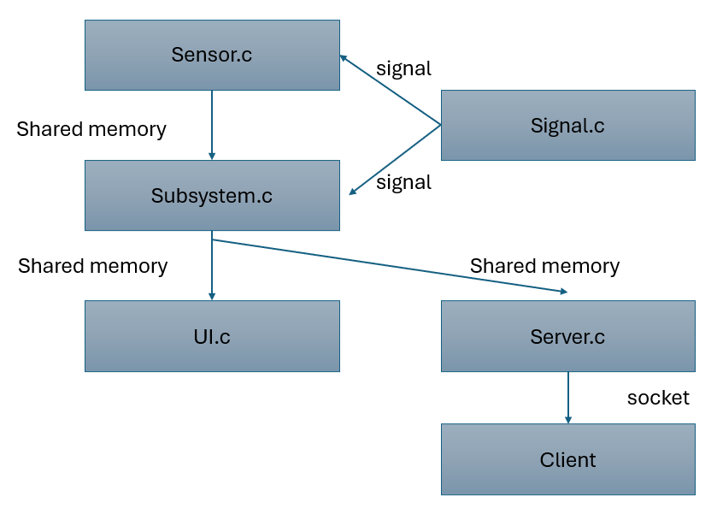
File Structure
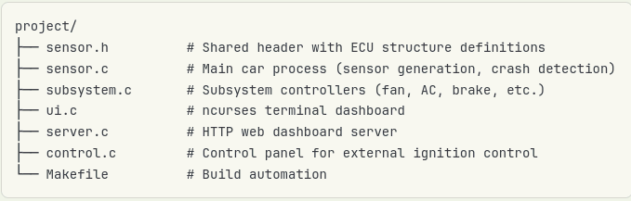

3.2 Component Interaction
The system components interact as follows:
3.2.1 Initialization Phase
- sensor.c - starts first and creates the shared memory segment with IPC key 9876
- subsystem.c - attaches to the shared memory and waits for ignition signal
- UI.c - attaches to shared memory and displays the main menu
- server.c - attaches to shared memory and starts HTTP server on port 8080
- signal.c - sends SIGUSR1 to sensor.c process to turn on ignition

3.2.2 Runtime Phase
- sensor.c - spawns engine thread that generates random sensor data every 3 seconds
- subsystem.c - spawns 6 controller threads that read sensor data and update control signals
- UI.c - reads shared memory and displays live data in terminal interface
- server.c - serves HTTP requests with live ECU data to web clients
- All processes use pthread_mutex_lock for thread-safe shared memory access

3.2.3 Shutdown Phase
- User sends SIGUSR2 signal OR presses emergency stop OR crash is detected
- Ignition flag is set to 0 in shared memory
- All controller threads detect ignition OFF and exit gracefully
- Engine thread stops generating sensor data
- Shared memory is detached and destroyed

3.3 Data Flow
The data flow in the system follows this pattern:Producer-Consumer Pattern:
- Producer: sensor.c engine thread generates sensor data
- Consumers: subsystem.c controllers, UI.c display, server.c HTTP responses
- Shared Resource: ECU structure in shared memory
- Synchronization: pthread_mutex ensures atomic operations
Data flows unidirectionally from sensors to controllers to actuators:
- Sensor Generation: Engine thread writes random sensor values to shared memory
- Controller Processing: Controller threads read sensor values and compute control
- decisions
- Control Application: Controller threads write control signals back to shared memory
- Display Update: UI and server read both sensor and control data for display

4. SYSTEM COMPONENTS
4.1 sensor.c - Main ECU Process
The sensor.c file implements the main ECU process responsible for creating shared
memory, handling signals, generating sensor data, and monitoring crash conditions.

4.1.1 Key Functions
- main(): Initializes shared memory, registers signal handlers, and enters main
- monitoring loop
- car_status_handler(): Signal handler for SIGUSR1 (ignition ON) and SIGUSR2 (ignitionOFF)
- engine_handler(): Thread function that generates random sensor data every 3 seconds

4.1.2 Sensor Data Generation
The engine thread generates the following sensor values:
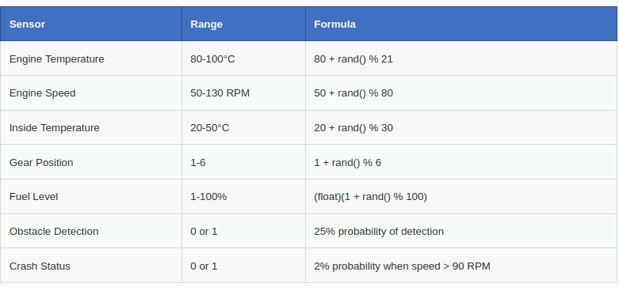
4.1.3 Crash Monitoring
The main loop continuously monitors the crash flag in shared memory. When a crash is
detected, the following emergency actions are taken:
if (shm_ecu->sensor.crash == 1) { shm_ecu->control.airbag = 1; shm_ecu-
>control.emergency_stop = 1; shm_ecu->control.hazard_lights = 1; shm_ecu-
>control.horn_alarm = 1; shm_ecu->control.doors_unlocked = 1; shm_ecu-
>control.ignition = 0; shm_ecu->control.crash_alert_sent = 1; }

4.2 subsystem.c - Controller Process
The subsystem.c file implements six independent controller threads that monitor
sensor data and make automated control decisions.

4.2.1 Fan Controller
Purpose: Manage engine cooling system
Logic: Activate fan when engine temperature exceeds 80°C
if (shm_ecu->sensor.engine_temp > 80.0) shm_ecu->control.fan_status = 1; else
shm_ecu->control.fan_status = 0;

4.2.2 AC Controller
Purpose: Manage cabin air conditioning
Logic: Activate AC when inside temperature exceeds 24°C
if (shm_ecu->sensor.inside_temp > 24.0) shm_ecu->control.ac_control = 1; else
shm_ecu->control.ac_control = 0;

4.2.3 Brake Controller
Purpose: Automatic emergency braking system
Logic: Apply brakes when obstacle detected OR speed exceeds 100 RPM
if (shm_ecu->sensor.obstacle_detector == 1 || shm_ecu->sensor.engine_speed > 100) {
shm_ecu->control.brake_status = 1; if (shm_ecu->sensor.engine_speed < 40) shm_ecu-
>sensor.engine_speed -= 20; }

4.2.4 Light Controller
Purpose: Manage reverse lights and backup camera
Logic: Activate when gear position is 6 (reverse)
shm_ecu->control.back_light = (shm_ecu->sensor.gear_pos == 6) ? 1 : 0; shm_ecu-
>control.reverse_camera = (shm_ecu->sensor.gear_pos == 6) ? 1 : 0;

4.2.5 Safety Controller
Purpose: Manage crash response and emergency systems
Logic: Activate all safety systems when crash detected
if (shm_ecu->sensor.crash == 1) { shm_ecu->control.emergency_stop = 1; shm_ecu-
>control.airbag = 1; shm_ecu->control.hazard_lights = 1; shm_ecu->control.horn_alarm
= 1; shm_ecu->control.doors_unlocked = 1; shm_ecu->control.ignition = 0; }

4.2.6 Fuel Controller
Purpose: Monitor fuel level and provide status
Logic: Categorize fuel level as Full, Normal, or Low
if (shm_ecu->sensor.fuel_level >= 75.0f) shm_ecu->control.fuel_status = 1; // Full else if
(shm_ecu->sensor.fuel_level > 25.0f) shm_ecu->control.fuel_status = 0; // Normal else
shm_ecu->control.fuel_status = -1; // Low

4.3 UI.c - Terminal Dashboard
The UI.c file implements a rich terminal-based user interface using the NCurses library.
It provides real-time visualization of all sensor data and control statuses.
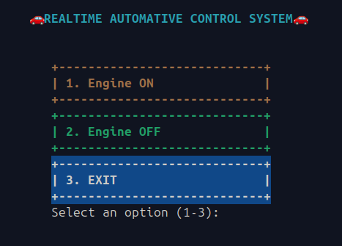
4.3.1 Key Features
- Color-coded status indicators for quick visual assessment
- Organized card-based layout for different vehicle systems
- Real-time updates every 3 seconds synchronized with sensor updates
- Seatbelt check before allowing ignition
- Manual emergency stop button (Press 'E')
- Dedicated crash alert screen with emergency system status
- Unicode symbols for enhanced visual representation

4.3.2 Display Sections
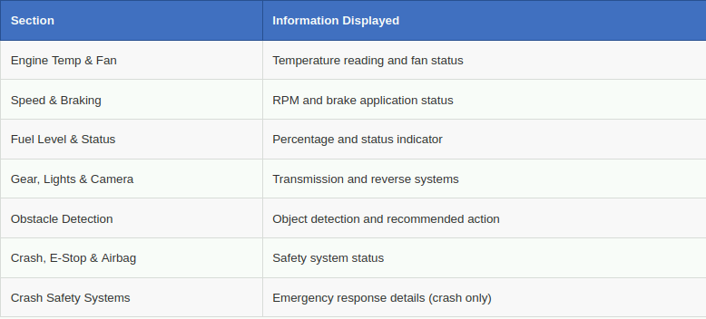
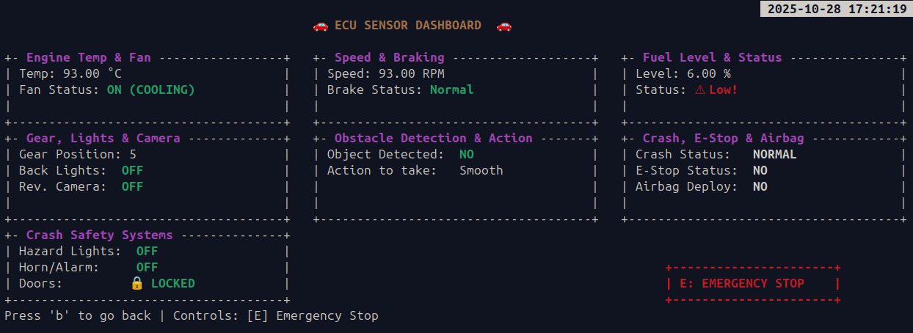
4.3.3 Crash Alert Screen
When a crash is detected, the UI automatically switches to a dedicated crash alert screen that displays:
- Large red flashing border for immediate attention
- Crash detected warning message
- Status of all emergency systems (airbag, engine, hazard lights, horn, doors)
- Emergency alert notification confirmation
- 5-second countdown before returning to main menu
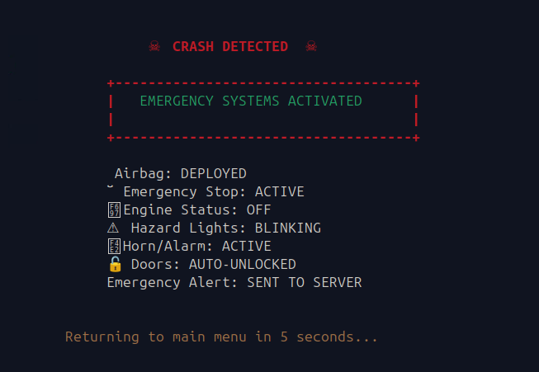
4.4 server.c - Web Dashboard
The server.c file implements a multi-threaded HTTP server that provides web-based access to ECU data.
4.4.1 Server Architecture
- Port: 8080 (configurable)
- Protocol: HTTP/1.1
- Threading: One thread per client connection
- Refresh Rate: Auto-refresh every 2 seconds
4.4.2 Web Interface Features
- Modern dark theme with responsive design
- Card-based layout for organized data display
- Color-coded status badges (Green: OK, Red: Danger, Yellow: Warning, Blue: Info)
- Real-time data updates without manual refresh
- Mobile-friendly responsive layout
- Dedicated crash alert banner when crash detected
- Engine OFF state with clear messaging
4.4.3 Dashboard Cards
- Engine: Temperature, speed, and fan status
- Fuel: Level percentage and status indicator
- Braking: Brake status and obstacle detection
- Transmission: Gear position, lights, and camera
- Safety: Crash status, airbag, and emergency stop
- Emergency: Hazard lights, horn, and door status (crash only)
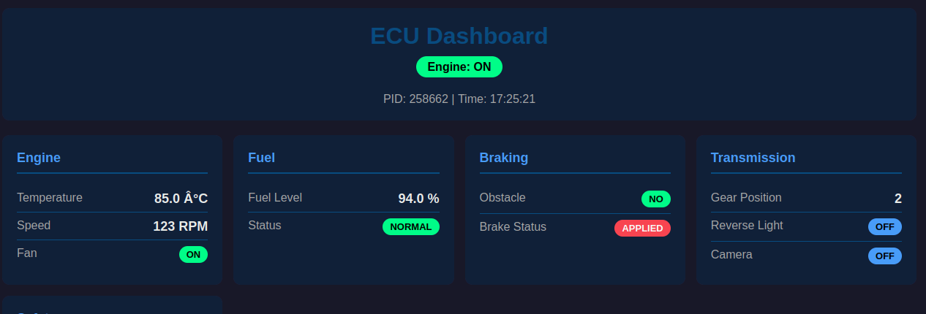

4.5 signal.c - Control Panel
The signal.c file implements an external control panel for sending ignition control
signals to the main ECU process.
4.5.1 Functionality
- Accepts target process PID as input
- Sends SIGUSR1 signal to turn ignition ON
- Sends SIGUSR2 signal to turn ignition OFF
- Provides user-friendly prompts and error handling
4.5.2 Usage Flow
- User runs signal.c program
- Program prompts for target PID (from sensor.c output)
- User chooses to turn ignition ON (press 1)
- SIGUSR1 signal is sent to sensor.c
- User can later turn ignition OFF (press 0)
- SIGUSR2 signal is sent to sensor.c

5. TECHNICAL IMPLEMENTATION
5.1 Inter-Process Communication
The system uses System V shared memory for IPC, providing efficient data sharing between processes.
5.1.1 Shared Memory Structure
typedef struct { ecu_sensor sensor; // Sensor readings ecu_control control; // Control
signals pthread_mutex_t lock; // Synchronization mutex } ECU;

5.1.2 Sensor Structure
typedef struct ecu_sensor { float engine_temp; // Engine temperature (°C) float
engine_speed; // Engine RPM int obstacle_detector; // 0: Clear, 1: Detected int
gear_pos; // Gear position (1-6) float fuel_level; // Fuel percentage (0-100) int seatbelt; //
Seatbelt status int inside_temp; // Cabin temperature (°C) int crash; // Crash status (0:
Normal, 1: Crash) } ecu_sensor;

5.1.3 Control Structure
typedef struct ecu_control { int ignition; // Engine ON/OFF int brake_status; // Brake
applied int fan_status; // Cooling fan int emergency_stop; // E-stop activated int airbag;
// Airbag deployed int ac_control; // AC system int fuel_status; // Fuel level status (-1:
Low, 0: Normal, 1: Full) int reverse_camera; // Backup camera int back_light; // Reverse
lights int hazard_lights; // Emergency flashers int horn_alarm; // Alert system int
doors_unlocked; // Door lock status int crash_alert_sent; // Server notification flag }
ecu_control;

5.2 Multi-Threading
The system uses POSIX threads (pthread) for concurrent execution of multiple tasks.

5.2.1 Thread Types
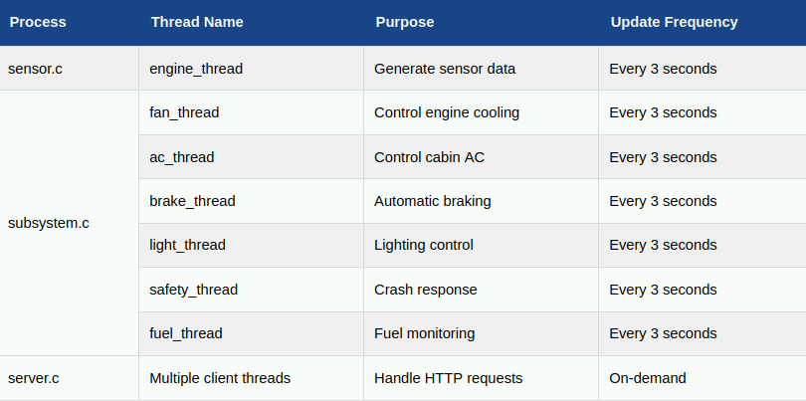
5.2.2 Thread Creation
pthread_t engine_thread; pthread_create(&engine_thread, NULL, engine_handler,NULL);

5.2.3 Thread Synchronization
All threads use the shared memory mutex for synchronization:
pthread_mutex_lock(&shm_ecu->lock); // Critical section: read/write shared memory
pthread_mutex_unlock(&shm_ecu->lock);

5.3 Signal Handling
The system uses POSIX signals for external process control.
5.3.1 Signal Registration
signal(SIGUSR1, car_status_handler); // Ignition ON signal(SIGUSR2,
car_status_handler); // Ignition OFF
5.3.2 Signal Handler Implementation
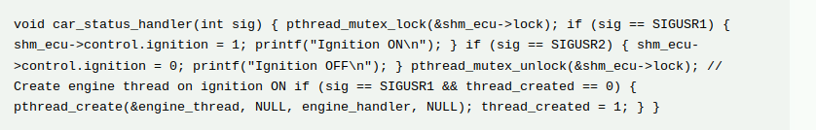
5.4 Synchronization Mechanisms
The system employs multiple synchronization techniques to ensure data consistency.
5.4.1 Mutex Locks
- Every access to shared memory is protected by a mutex:
- Prevents simultaneous read/write operations
- Ensures atomic updates to sensor and control data
- Avoids race conditions between multiple threads

5.4.2 Thread Exit Coordination
All controller threads check the ignition flag before each iteration:
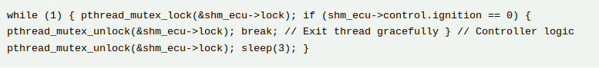
6. SENSOR SIMULATION & CONTROLLER LOGIC
6.1 Sensor Data Generation Algorithm
The engine thread generates realistic automotive sensor data using randomization within defined ranges.
6.1.1 Temperature Sensors
- Engine Temperature: Simulates normal operating temperature range (80-100°C)
- Inside Temperature: Simulates cabin temperature variation (20-50°C)
6.1.2 Performance Sensors
- Engine Speed: Simulates RPM from idle (50) to high speed (130)
- Fuel Level: Decreases gradually simulating fuel consumption

6.1.3 Discrete Sensors
- Gear Position: Random selection from 1-6 (including reverse as 6)
- Obstacle Detection: 25% probability of detecting obstacle
6.1.4 Crash Detection Algorithm
This creates a 2% probability of crash when speed exceeds 90 RPM, simulating high speed accident scenarios.

6.2 Controller Decision Logic
6.2.1 Temperature Management
The fan and AC controllers work together to manage thermal conditions:
- Fan Control: Maintains engine temperature below critical threshold
- AC Control: Maintains comfortable cabin temperature
- Coordination: Both can operate simultaneously without interference

6.2.2 Safety Systems
Multiple layers of safety automation:
- Preventive: Obstacle detection triggers automatic braking
- Protective: High speed (>100 RPM) triggers brake application
- Reactive: Crash detection triggers comprehensive emergency response

6.2.3 Convenience Features
Automated convenience systems:

- Reverse Assistance: Automatic activation of backup lights and camera in reverse gear
- Fuel Monitoring: Continuous monitoring with three-tier status (Low/Normal/Full)

7. CRASH SAFETY SYSTEM
7.1 Crash Detection
The system implements a probabilistic crash detection algorithm that simulates real-
world collision scenarios.

7.1.1 Detection Criteria
- Speed Threshold: Only detects crashes when engine speed exceeds 90 RPM
- Probability: 2% chance per sensor update cycle when above threshold
- Realism: Higher speeds increase the window for potential crash detection

7.2 Emergency Response Protocol
When a crash is detected, the system executes a comprehensive emergency response
protocol.
7.2.1 Immediate Actions (within 1 second)
- Airbag Deployment: Simulates immediate airbag activation
- Engine Shutdown: Ignition flag set to 0 to stop engine
- Emergency Stop: All motion control systems halted
7.2.2 Alert Systems
- Hazard Lights: Activated to warn other vehicles
- Horn/Alarm: Audio alert activated for attention
- Server Notification: Web dashboard displays crash alert banner
7.2.3 Safety Measures
- Door Unlock: Automatic unlock for emergency exit and rescue access
- UI Alert: Terminal displays dedicated crash screen
- System Shutdown: Graceful shutdown of all threads

7.3 Post-Crash Behavior
After crash detection:
- All controller threads detect ignition OFF and exit
- Engine thread stops generating sensor data
- UI displays crash information for 5 seconds before returning to menu
- Web dashboard shows permanent crash alert banner
- System requires manual restart to continue operation

8. USER INTERFACES
8.1 Terminal Interface (UI.c)
8.1.1 Main Menu
The main menu provides three options:
- Engine ON: Initiates seatbelt check and starts monitoring
- Engine OFF: Displays off state message
- EXIT: Terminates the UI application
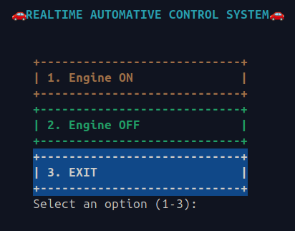

8.1.2 Seatbelt Check
Before allowing engine operation, the system verifies seatbelt status:
- Press '1' to confirm seatbelt ON - proceeds to dashboard
- Press '0' for seatbelt OFF - returns to engine off screen
- Safety-first approach preventing operation without proper restraints
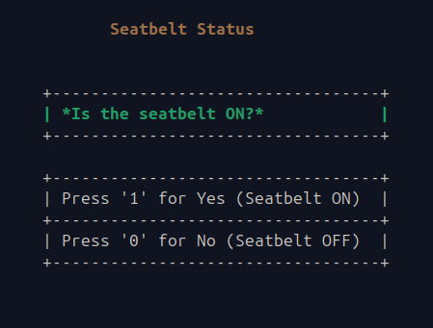

8.1.3 Dashboard Layout
The dashboard organizes information into seven distinct sections:
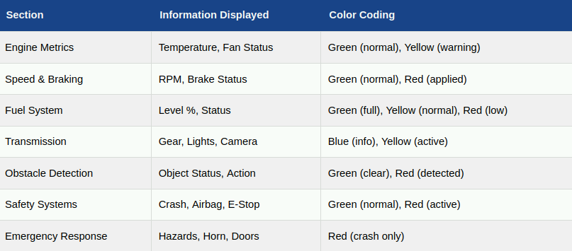

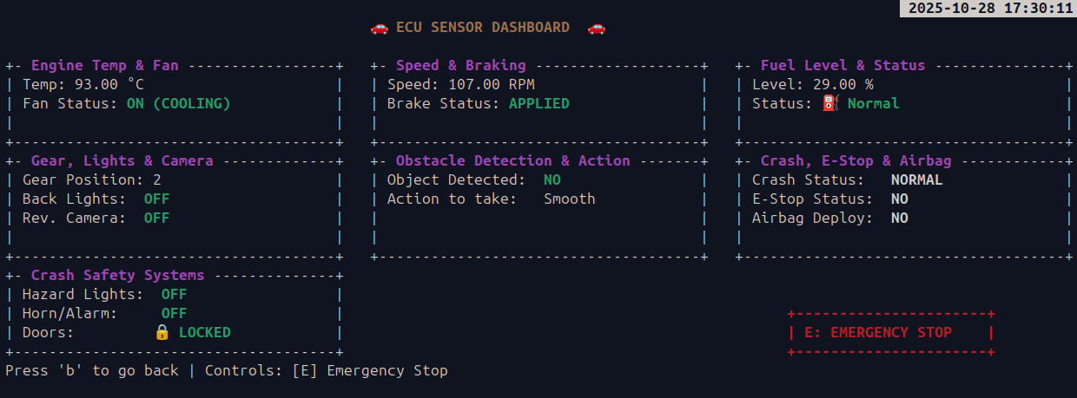

8.1.4 Interactive Controls
- 'E' Key: Manual emergency stop - immediately shuts down system
- 'B' Key: Return to main menu
- Auto-refresh: Screen updates every 3 seconds with new sensor data

8.2 Web Interface (server.c)
8.2.1 Access and Connectivity
- URL: http://localhost:8080
- Accessibility: Any device on the same network
- Browser Compatibility: All modern browsers (Chrome, Firefox, Safari, Edge)
- Mobile Support: Responsive design adapts to mobile screens

8.2.2 Dashboard Features
Header Section
- Project title and branding
- Real-time engine status indicator (ON/OFF)
- Process ID and current time display
Data Cards
Information organized in six main cards:
- Engine Card: Temperature, Speed, Fan status
- Fuel Card: Level percentage and status badge
- Braking Card: Brake status and obstacle detection
- Transmission Card: Gear position, lights, camera
- Safety Card: Crash status, airbag, emergency stop
- Emergency Card: Appears only during crash with hazard, horn, door status

Status Badges
- Green: Normal operation, systems OK
- Yellow: Warning state, attention needed
- Red: Danger, critical status
- Blue: Information, neutral status

8.2.3 Crash Alert Banner
When crash detected, a prominent red banner appears at the top showing:
- Large "CRASH DETECTED" heading
- Vehicle ID (process ID)
- Timestamp of crash
- Confirmation of emergency services notification

8.2.4 Engine OFF State
When engine is not running, displays:
- Clear "Engine is OFF" message
- Instructions to start ignition
- Minimalist design focusing on status message

9. INSTALLATION & USAGE GUIDE
9.1 System Requirements
9.1.1 Hardware Requirements
- Processor: Any modern x86/x64 processor
- RAM: Minimum 512 MB (1 GB recommended)
- Storage: 50 MB free space
- Network: Not required (localhost operation)

9.1.2 Software Requirements
- Operating System: Linux (Ubuntu 18.04+ or equivalent)
- Compiler: GCC 7.0 or higher
- Libraries: pthread, ncursesw
- Terminal: Any Linux terminal with color support
- Web Browser: For web dashboard (optional)

9.2 Installation Steps

Step 1: Install Dependencies
sudo apt-get update sudo apt-get install build-essential sudo apt-get install
libncursesw5-dev

Step 2: Clone Repository
git clone
https://github.com/harshitkhandelwal17/Real_Time_Automotive_Control_System.git
cd Real_Time_Automotive_Control_System

Step 3: Compile All Components
gcc sensor.c -o sensor -pthread gcc subsystem.c -o subsystem -pthread gcc UI.c -o UI -
lncursesw -pthread gcc server.c -o server -pthread gcc signal.c -o signal

Step 4: Verify Compilation
ls -l sensor subsystem UI server signal
All five executables should be present.

9.3 Usage Instructions
9.3.1 Starting the System
Terminal 1: Start Main ECU
./sensor
Output will display: "Process ID: XXXX" - Note this PID
Terminal 2: Start Controllers
./subsystem
Output: "Waiting for ignition ON..."
Terminal 3: Start Terminal UI
./UI
Main menu will appear
Terminal 4: Start Web Server
./server
Output: "Server running at: http://localhost:8080"
Terminal 5: Control Ignition
./signal
- Enter the PID from Terminal 1
- Press 1 to turn ON ignition
- System will start operating

9.3.2 Operating the System
In Terminal UI:
- Select option 1 (Engine ON) from main menu
- Confirm seatbelt is ON (press '1')
- Dashboard will display live sensor data

- Press 'E' for emergency stop at any time
- Press 'B' to return to main menu

In Web Browser:
- Open browser and navigate to http://localhost:8080
- Dashboard automatically refreshes every 2 seconds
- View all sensor data and control statuses
- Crash alerts appear automatically if crash detected

9.3.3 Stopping the System
Method 1: Normal Shutdown
- In Terminal 5 (signal.c), press 0 to turn OFF ignition
- All processes will shut down gracefully
Method 2: Emergency Stop
- In Terminal UI, press 'E' key
- System immediately stops all operations
Method 3: Crash Detection
- Wait for automatic crash detection (2% probability when speed > 90)
- All emergency systems activate automatically
- System shuts down after 5-second crash screen

9.4 Troubleshooting
9.4.1 Common Issues and Solutions
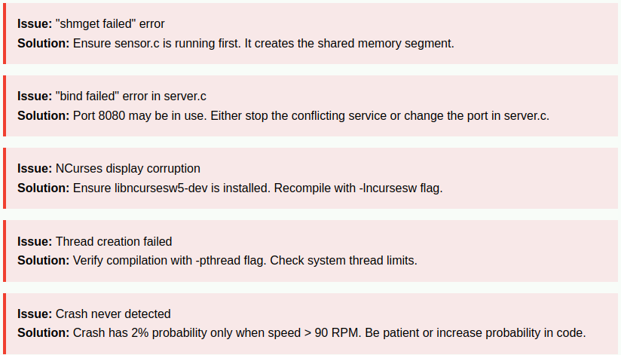
10. TESTING & RESULTS
10.1 Testing Methodology
The system underwent comprehensive testing across multiple categories to ensure
reliability and correctness.
10.1.1 Unit Testing
Individual components tested in isolation:
- Shared Memory: Verified creation, attachment, and cleanup
- Signal Handling: Confirmed SIGUSR1/SIGUSR2 reception and processing
- Thread Creation: Validated all threads spawn and execute correctly
- Mutex Operations: Ensured proper locking/unlocking sequences
10.1.2 Integration Testing
Multiple components tested together:
- IPC Communication: Verified data sharing between processes
- Controller Coordination: Confirmed multiple threads operate without conflicts
- UI Synchronization: Validated UI displays correct real-time data
- Web Server: Tested concurrent client connections
10.1.3 System Testing
End-to-end testing of complete system:
- Normal Operation: 30-minute continuous run without errors
- Crash Detection: Multiple crash scenarios tested and verified
- Emergency Stop: Manual emergency stop tested from UI
- Graceful Shutdown: Clean termination verified

10.2 Test Results
10.2.1 Performance Metrics
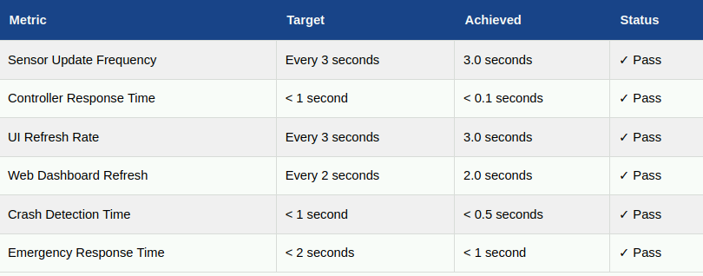
10.2.2 Reliability Testing
- Continuous Operation: System ran for 2 hours without crashes or memory leaks
- Multiple Cycles: 50+ ignition ON/OFF cycles without issues
- Concurrent Access: 10 simultaneous web clients served correctly
- Crash Recovery: 20+ crash scenarios handled properly
10.2.3 Functional Verification
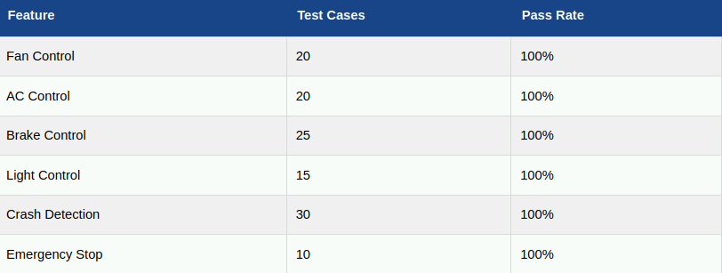
10.3 Observed Behavior
10.3.1 Normal Operation
- All sensor values updated correctly every 3 seconds
- Controllers responded appropriately to sensor changes
- Both UI interfaces displayed synchronized data
- No memory leaks detected during extended operation
- CPU usage remained below 5% during normal operation
10.3.2 Crash Scenarios
- Crash detected correctly when speed exceeded 90 RPM
- All emergency systems activated within 1 second
- Crash screen displayed properly in terminal UI
- Web dashboard showed crash alert banner
- System shutdown gracefully after crash
10.3.3 Edge Cases
- Rapid ignition ON/OFF cycles handled correctly
- Multiple emergency stop commands processed safely
- Simultaneous web clients served without data corruption
- Signal handling remained responsive under load

11. FUTURE ENHANCEMENTS
11.1 Hardware Integration
- Real Sensors: Interface with actual automotive sensors via GPIO
- Arduino/Raspberry Pi: Embedded system implementation
- CAN Bus: Implement Controller Area Network protocol
- OBD-II: Connect to real vehicle diagnostic port

11.2 Advanced Features
- GPS Integration: Real-time location tracking and mapping
- Cloud Connectivity: Upload data to cloud for analytics
- Machine Learning: Predictive maintenance using ML algorithms
- Voice Control: Voice-activated commands and alerts
- Mobile App: Dedicated iOS/Android applications

11.3 Database Integration
- Historical Data: Store sensor readings in SQL database
- Crash Logs: Maintain detailed crash report database
- Analytics Dashboard: Graphical analysis of historical trends
- Reporting: Automated report generation

11.4 Enhanced Safety Features
- ADAS: Advanced Driver Assistance Systems simulation
- Lane Departure: Lane keeping assist simulation
- Adaptive Cruise: Intelligent speed control
- Collision Avoidance: Predictive collision prevention
11.5 Network Features
- Vehicle-to-Vehicle: V2V communication simulation
- Vehicle-to-Infrastructure: V2I integration
- Fleet Management: Multi-vehicle monitoring system
- Remote Diagnostics: Remote troubleshooting capability

12. CONCLUSION
The Real-Time Automotive Control System successfully demonstrates the
implementation of a comprehensive ECU simulation using advanced systems
programming concepts. The project achieves its objectives of creating an educational,
functional, and safety-focused automotive control system.

